**Kol simcha torah gazette**

**For parshas toldos 5784**

Volume 8 Issue 10 (Whole #368) 5 Kislev 5784/ November 18, 2023

**Printed L’illuy nishmas Nechama bas R’ Noach, a”h**

For a free subscription, please forward your request to [***keren18@juno.com***](mailto:keren18@juno.com)

***Past emails can be found on the website ShabbosStories.com under Brooklyn Torah Gazette***

**A Family’s Tragedy in Israel Unites Jews from Near and Far**

**By**[**Howard Blas**](https://www.chabad.org/search/keyword_cdo/kid/21874/jewish/Blas-Howard.htm)

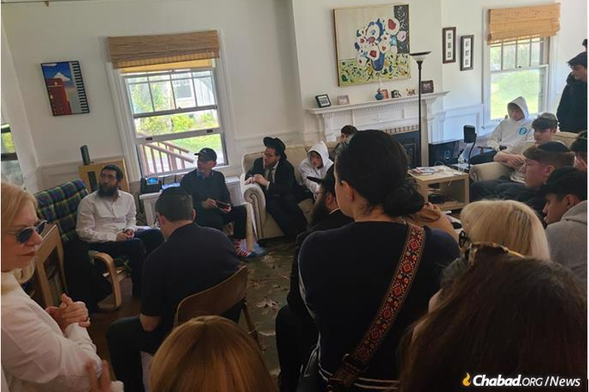

**Shnaider (center left, in baseball cap) sits**[**shiva**](https://www.chabad.org/library/article_cdo/aid/282452/jewish/Mourning-Observances-of-Shiva-and-Shloshim.htm)**in his home in Kingston, N.Y.** *Photo: Rabbi Yitzhak Hecht*

Margit and Yosi Silverman were [murdered on Oct. 7](https://www.chabad.org/library/article_cdo/aid/6119349/jewish/Israel-at-War.htm) by Hamas terrorists in their home in Kibbutz Nir Oz, Israel. Though initially thought to have been taken hostage, they were soon identified and buried on the Monday after Simchat Torah.

Some 5,600 miles away, in Kingston, N.Y., Margit’s brother, Maurice Shnaider, suddenly became a mourner. The Peru-born, longtime resident of Colorado had just recently moved to Kingston, where he’d joined the [Chabad-Lubavitch of Ulster County](https://www.chabad.org/jewish-centers/150727/Kingston/Synagogue/Chabad-of-Ulster-County) Jewish community, and he wondered whether he’d be able to even gather a quorum for prayers during the week-long [*shiva*](https://www.chabad.org/library/article_cdo/aid/281584/jewish/What-Is-Shiva.htm)[mourning period](https://www.chabad.org/library/article_cdo/aid/281584/jewish/What-Is-Shiva.htm).

**People Came From Three or Four Hours Away**

“I hoped we could gather 10 or 20 people,” says Shnaider. Instead, over the next week, 800 people showed up for *shiva*. “Some people came from three and four hours away.”

Kingston Jewish community member Michelle Tuchman was amazed by the scene. “Each night, hundreds of people came—even buses of people,” she says. “They came from Philadelphia, New Jersey and Montreal. I was so touched watching these young people coming to Maurice’s house.”

Howard Vichinsky, president of Chabad of Ulster, was similarly struck by the numbers and range of people who came to comfort Maurice and his family.

“People came from all over to pay their respects and to show their support and sympathy for the living,” he says. “They came from Lakewood, Englewood, Teaneck [New Jersey]; *yeshivahs* in Monsey and Riverdale, and in Durham [New York]; the local Reform temple; buses from junior high schools and high schools, Yeshiva University—way beyond our community.”

Vichinsky was particularly touched by a large group that came from a Chassidic *yeshivah* in Monsey, N.Y. “They came and sang beautiful songs in his home; you could see how comforting an act that was.”

About 50 people came the first night, says Vichinsky, then 150 on the second night, and 250 on the third. They came throughout the day—not just at *minyan* times—and stayed for hours.

“No one had ever seen anything like this,” he says. “Certainly not in Kingston.”

**Tears and Dancing**

Rabbi Yitzhak Hecht, together with his wife, Leah, directs [Chabad](https://www.chabad.org/library/article_cdo/aid/244369/jewish/About-Chabad-Lubavitch.htm) of Ulster County. He began to learn of the mass terror attack in Israel as Shabbat—[Simchat Torah](https://www.chabad.org/library/article_cdo/aid/4583/jewish/How-to-Celebrate-Simchat-Torah.htm) in Israel and Shemini Atzeret abroad—progressed. He included additional *Tehillim* (“Psalms”) in the service but also placed an additional emphasis on “wiping out the negatives with positives” by stressing the need to rejoice in the holiday even more so than usual.

“We knew we needed to have more *simcha* [joy] than usual,” he recalls. Simchat Torah is the day the Jewish people dance together with the [Torah](https://www.chabad.org/library/article_cdo/aid/1426382/jewish/Torah.htm), so “we danced our hearts out. That is what [the Rebbe](http://therebbe.org/) [Rabbi Menachem M. Schneerson, of righteous memory,] would have wanted us to do. He would want every Jew to do another mitzvah and another as a way of responding.”

**After the Holiday, Rabbi Hecht Learned**

**That One of Their Own Had Been Affected**

When the holiday was out and the full-scope of the horror had set in, Rabbi Hecht and the community learned that not only had hundreds of their brethren been slaughtered in the Holy Land, but that one of their own had been directly affected.

Not only were Shnaider’s sister and brother-in-law among the murdered: Maurice’s niece and nephew, Shiri (Silverman) and Yarden Bibas, and their two sons, Ariel, 4, and Kfir, who just turned 10 months old, were kidnapped and are currently being held captive by Hamas in Gaza. Awful images of Shiri holding her two red-headed boys as they’re being taken by Hamas are among those seared into the public’s minds from that terrible day.

“This horrible event was just a big blow to the whole community,” says Vichinsky. “Anyone who came to pay respects for Maurice’s loss was also paying respects for a tragedy that happened to all Jews that day—in Israel, and by extension, to all of us.”

Maurice, his wife Cindy and the youngest of their three boys had only joined the Kingston community a few months ago, but already they’ve become cherished members, with all the little things that come along with that: At one point, Maurice had mentioned to the rabbi that he’d owned and operated a coffee shop in Denver. Ever since, he’s been brewing fresh coffee for everyone who comes to the Kingston morning [*minyan*](https://www.chabad.org/library/article_cdo/aid/543104/jewish/Why-Are-Ten-Men-Needed-for-a-Minyan.htm) on Mondays and Thursdays.

But Hecht was still touched when he observed how deeply the community came together to support Maurice and his family. “The unity we saw was uplifting. Everyone felt that we are all in it together,” he says. “From that alone, Moshiach should come!”

**‘This Is What Unity Looks Like’**

On the Thursday morning after the attack, *shiva*was held at Chabad, following morning prayers, and included a community gathering held on the synagogue’s front lawn. Standing together with the Shnaider family were Rabbi Hecht and fellow Chabad of Ulster Rabbi Avraham (A.B.) Itkin, and in attendance were local politicians, among them the mayor and other elected officials, as well as the media and Jewish and non-Jewish community members.

“We are standing under a sign that says ‘Do a [Mitzvah](https://www.chabad.org/library/article_cdo/aid/1438516/jewish/Mitzvah.htm) for Israel,’ ” Hecht told the gathered. “We have to do mitzvahs, and acts of goodness and kindness [with which] we can change the world and make it a better place—a G‑dly place and a holy place.”

Praying for the coming of Moshiach—a time of peace and no war—might sound like a dream, Hecht said, “but you know what? We are living in a dream now with all of the negatives. Why have a bad dream if we can live in a good dream?

[Let’s] make that good dream a reality.”

Hecht was followed by Maurice, who thanked everyone for joining. Maurice spoke of his “sense of belonging amid the grief and loss” and discovering that while he’d lost his sister, “I have gained an extended family, bound by the ties of G‑d, Judaism and compassion.” He spoke of the Rebbe’s charge to battle the forces of darkness with acts of goodness and kindness.

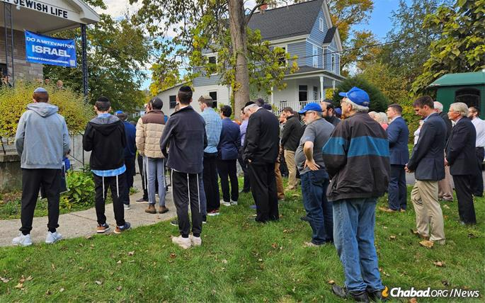

**Throughout the week, hundreds made the trek to Kingston to comfort Shnaider, some driving hours to be there with him and his family.**

*Photo: Bruce Tuchman*

Tuchman, who was at the gathering, says she was touched by Shnaider’s remarks at the communal event, noting especially that Shnaider had indicated that at some point in the near future, he wanted to host a party in his home where all of the people who came for *shiva* could come back “for a good cause.”

Tuchman was also moved by presentations and remarks of the two rabbis, Hecht and Itkin.“It was very emotional,” she says, meaning both the communal event and the general *shiva*. “It was both very sad and very joyful.”

As the week of *shiva* drew to a close, Shnaider spoke about “going back to my family and myself.” He admitted that he was feeling exhausted from interacting with so many who came to offer comfort but full of thankfulness as well.

“People came to comfort me, but I was comforting them, too,” he says thoughtfully. “This wasn’t only for me. They were doing it for *Am Yisrael*[the Jewish people]. People came here to make a connection to Israel and to being Jewish, and this was the unity that I saw. *B’yachad*—‘together’—is the word I keep using. This is what unity looks like.”

Reprinted from the November 7, 2023 website of Chabad.Org

**Thoughts that Count**

**For Our Parsha**

*The one people shall be stronger than the other people* (Gen. 25:23)

As Rashi comments, "When one rises, the other shall fall." Jacob and Esau are symbolic of the struggle between the G-dly soul and the animal soul. When a Jew's G-dly soul is strengthened and "rises up," he does not have to fight his Evil Inclination in a direct manner. Rather, the animal soul automatically "falls" in its presence, in the same way that darkness is automatically dispelled in the presence of light. (Sefer HaMaamarim)

*And Isaac loved Esau...but Rivka loved Jacob* (Gen. 25:25)

Isaac was a "perfect offering," whose "style" of Divine service was somewhat removed from the material world and its concealments. Rivka, by contrast, had grown up in household surrounded by devious people. When Esau asked his father how to "tithe salt," it was beyond Isaac's imagination that his son was being deceitful. Rivka, however, with her experience in the ways of the world, recognized that it was only a scheme to impress his father, and "loved Jacob" for his quality of truthfulness. (Der Torah Kval)

*Reprinted from the Parshat Toldot 5761/2000 edition of L’Chaim.*

**Rav Avigdor Miller on**

**Celebrating Thanksgiving**

**With a Turkey Dinner?**

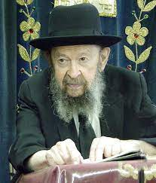

**QUESTION:** What is your opinion about celebrating the holiday of Thanksgiving with a turkey dinner?

**ANSWER:** Thanksgiving is a holiday that was manufactured by gentiles for the purpose of going to church. That’s what the original purpose was. It’s only recently that it became a ‘legal holiday.’ But it used to be a Christian holiday and that’s what it is all the way down till today.

And because it’s not a legal holiday alone, therefore it’s avodah zarah and Jews are forbidden to participate in such a thing, to eat a turkey dinner. Even if the turkey doesn’t have religious symbolism, because it’s connected with the holiday and the holiday itself has religious symbolism, that’s enough to make it forbidden. There’s a Gemara that says it’s forbidden to wear laurel leaf on the day of a certain gentile avodah zarah. Now, laurel leaf has no religious significance. But because the gentiles wear laurel on that day, it’s forbidden.

And so, if you eat turkey especially for Thanksgiving, you’re an oved avodah zarah. That’s my opinion. Some people are weak in this matter but I think it’s real avodah zarah. I think that a Jew should make a sacrifice not to eat turkey. However, like I told you earlier there are those who permit it and even though I say it’s all wrong I’m not going to force my opinion on you. But if anybody in my synagogue would ask me such a question, I would give it to him. But since you’re not in my synagogue, I’ll let you go.

*Reprinted from the Parshas Chayei Sarah 5784 email of Toras Avigdor based on Tape #R-30 (November 1972).*

**The Importance of the**

**“Generations of Isaac”**

**From the Teachings of the Lubavitcher Rebbe**

**Rabbi Menachem Mendel Schneerson, Zt”l**

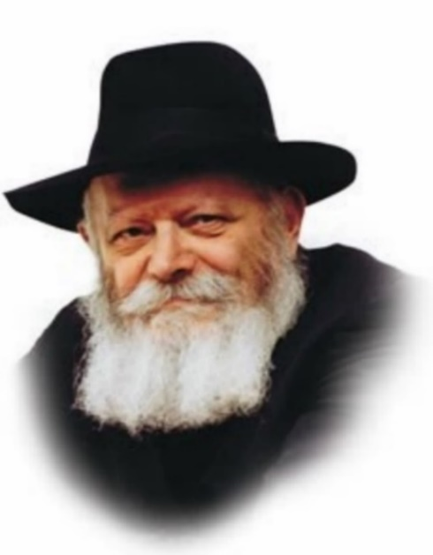

In this week's Torah portion, Toldot, we read of the birth of Esau and Jacob, Esau's sale of his birthright to Jacob and the subsequent blessing of Jacob and Esau by Isaac.

Jewish teachings explain that the name of a particular Torah portion gives us a special insight into that portion. The name of the portion, Toldot, is derived from its opening words: "And these are the generations (toldot) of Isaac." An earlier Torah portion, Noach (Noah), begins with a similar verse, "These are the generations of Noah."

What is the essential difference between these two portions, as reflected in the Torah's choice of names?

The portion of Toldot emphasizes the concept of descendants. "And these are the generations of Isaac, the son of Abraham: Abraham begot Isaac."

Toldot, related to the Hebrew word for birth (holada), implies both physical offspring and spiritual heirs. When we help a fellow Jew by teaching him about the beauty and warmth of Judaism, we create new "generations," new spiritual children. Even if we are not well-versed in Torah knowledge or the practice of mitzvot, whatever we do know we should share with others. Every Jew has the obligation to act as a "candle" unto his surroundings, spreading the light and warmth of Torah to more and more Jews.

The "generations" we create, however, must be "the generations of Isaac"; it is not enough that we produce "the generations of Noah."

To explain: The name Noah is related to the word n'yacha, meaning rest and repose. Noah is symbolic of a person who is tranquil. It is a desirable state, but one that is less elevated than the level implied by the name Isaac.

**The Importance of Laughter and Delight**

Isaac (Yitzchak in Hebrew) is related to the word meaning laughter. Isaac is thus a symbol of the joyful person, one who is filled with laughter and delight. Enjoyment is obviously a more desirable state than relaxation, for the person is not only at rest but is happy.

This, then, is the way in which we are to fulfill our mission as "candles that illuminate": It isn't enough for a Jew to quietly share the light of Torah and mitzvot throughout the world in a sedate and easy-going manner. Rather, as we learn from the Torah portion of Toldot, our efforts to inspire our fellow Jews in particular and be a "light unto the nations" in general must be carried out with joy and happiness, as alluded to by the name Isaac.

*Reprinted from the Parshat Toldot 5761/2000 edition of L’Chaim. Adapted from Volume 1 of Hitva’aduyot 5744.*

*\*\*\*\*\*\*\*\*\*\*\*\*\*\*\*\*\*\*\*\*\*\*\*\*\*\*\*\*\*\*\*\*\*\*\*\*\*\*\*\*\*\*\*\*\*\*\*\*\*\*\*\*\*\*\*\*\*\*\*\*\*\*\*\*\*\**

*And the man became rich, and gained more and more, until he became very wealthy* (Gen. 26:13)

It often happens that the richer a person gets, the smaller his essential "humanity" and regard for his fellow man becomes. Isaac, however, not only retained his quality of being a "man" the wealthier he grew, but continued his rise to perfection as an empathetic human being. (Rabbi Yitzchak of Torchiv)

Behold, I heard your father speak to Esau your brother (Gen. 27:6)

*Reprinted from the Parshat Toldot 5761/2000 edition of L’Chaim.*

**Rabbi Berel Wein on**

**Parshat Toldot 5784**

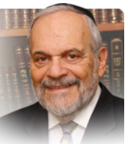

The troubling question that has persisted throughout the ages of Biblical commentary on this week’s parsha is: What is Yitzchak thinking in regard to giving the blessings and heritage of Avraham to Eisav? Basically, the comments and explanations fall into two categories. One of them is that Yitzchak is fooled by Eisav and is really unaware of his true nature and wanton behavior.

Rashi, quoting Midrash, interprets that Eisav “hunted“ his father with his pious speech and cunning conversation. Yitzchak is fooled by Eisav and believes that Eisav, the man of the world and the physically powerful figure is better suited to carry on Avraham’s vision than is Yaakov, the more studious and apparently more simple of the brothers.

The other opinion, more popular among the later commentators to the Torah, is that Yitzchak is aware of the shortcomings of behavior and attitude of his elder son. His desire to give the blessings to Eisav is due to his wish to redeem and save his son, and to enable Eisav to turn his life around and become a worthy heir to the traditions of his father and grandfather. He thinks that by somehow giving the blessings to Eisav, Yaakov will not really suffer any disadvantage in his life’s work, while Eisav will find his way back to holiness through the blessings that he has now received.

These two divergent attitudes towards the wayward child in Jewish families is one that is enacted daily in Jewish family life. Later Yitzchaks either willfully allow themselves to be deluded regarding the behavior and lifestyle of children or they are aware of the problem and attempt to solve it with a giving nature and a plethora of blessings.

Rivkah, Eisav’s mother, is not fooled by her son’s apparently soothing words nor does she believe that granting him blessings will somehow accomplish any major shift in his chosen lifestyle. To a great measure she adopts a policy of triage, saving Yaakov and blessing him while thus abandoning Eisav to his own chosen wanton ways.

The Torah does not record for us the “what if” scenario – what if Eisav had received the blessings would he then have been different in behavior and attitude, belief and mission. However, from the words of the later prophets of Israel, especially those of Ovadiah, it appears to be clear that G-d somehow concurred with Rivkah’s policy and holds Eisav to be redeemable only in the very long run of history and human events.

The verdict seems to be that one must be clear eyed and realistic about the painful waywardness and misbehavior of enemies of Yaakov, be they from within or without our immediate family and milieu. There are many painful choices that need to be made within one’s lifetime and especially in family relations.

There are few pat answers to varying and difficult situations. Perhaps that is why the Torah itself does not delve too deeply into the motives of Yitzchak and Rivkah but is content merely to reflect the different emotional relationships each had with their two very different sons. The Torah emphasizes the role that human emotions play in our lives and does not consign all matters to rational thought and decision-making.

*Reprinted from the current website of rabbiwein.com*

**Doctor Treating Victims**

**of the Hamas Massacre**

**By Shanna Fuld**

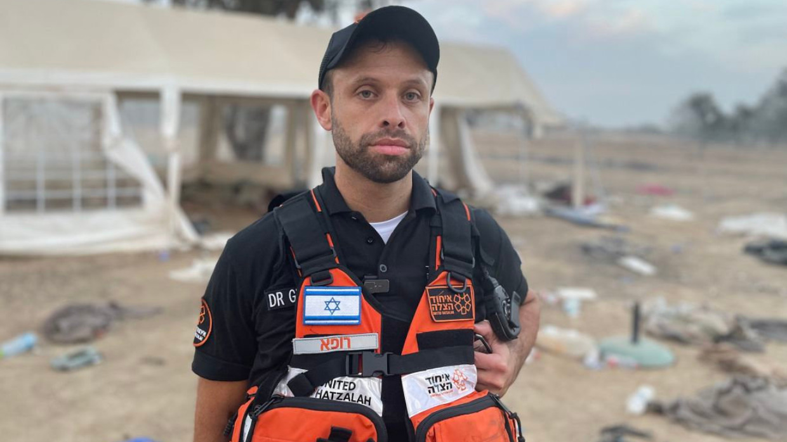

***Dr. Shlomo Gensler, a 38-year-old father of four, saved countless lives in the thick of massacre on October 7th, 2023.***

Dr. Shlomo Gensler, an Orthodox physician and father of four, found himself driving on the Sabbath to treat victims of the Hamas massacre.

He recalled the initial moments vividly in an interview with Aish.com. He had been at synagogue with his family when the first sirens went off in Jerusalem. Initially, no one knew what to expect.

Gensler works in the Intensive Care Unit at Hadassah hospital as his day job, but also volunteers with United Hatzolah. He got a call that morning asking him to assist people over the phone who had needed medical guidance. Those who were calling in were trapped in Israeli communities along the border and could not safely get out due to heavy terrorist fighting. At this point, he still didn’t understand exactly what was going on. His first call was a dire one.

"She explained to me that her father had both arms and legs blown off. He had bullet wounds to his torso," Gensler said. They were trapped in Kfar Aza.

“I asked the army to help them and they said no, and that they were overwhelmed,” Dr. Gensler explained. “When I called again, the family was trapped inside the *mamad* (safe room), and I heard bullets flying.”

Following this, Gensler was asked to venture down to the south. He went to what he called the “staging point” where Hatzolah had set up a make-shift workstation. Dr. Gensler loaded up his intensive care jeep with equipment, took an EMT with him and together, the two made their way.

**The Brutal Aftermath of the Conflict**

By the time they arrived at the scene around 12 noon, the area had already become a war-torn landscape and the two witnessed the brutal aftermath of the conflict. Gensler said it looked like scenes he’d envisioned from the Holocaust with cars blown up, flipped over, and houses and fields set on fire.

"We saw hundreds of bodies on the side of the road, people executed outside of their cars and cars crashed off to the side.”

In the town of Netivot, Dr. Gensler set up a triage amidst the chaos, tending to the wounded one after another with the help of fellow medical professionals. Working from the edge of Netivot, the small medical crew started treating patients on the backs of people's cars. People were arriving to the triage point in pick-up trucks and civilian cars. The only people entering the kibbutzim were Hatzolah ambulances and the army.

"We worked together as a team, driven by the knowledge that every second counted," he emphasized. “There was one paramedic who had been there since the morning and he explained the horrific stuff he had seen. And then we started experiencing it.”

**Working Next to Many Dead Bodies**

At one point, Dr. Gensler remembers working next to five to ten dead bodies. At one point, ZAKA (Israel Search and Rescue) came to take them away and clear the space for the men to work.

The afternoon was relentless, as waves of injured people arrived. Three blocks over from the triage point, a missile fell down next to an apartment building and a mass explosion was heard. Police officers were warning the medics that terrorists had been stealing police cars and killing officers.

“They told us that if you saw a police car coming, it didn't necessarily mean it was safe.”

Dr. Gensler and his team pressed on, creating a lifeline for soldiers and civilians alike, each bearing severe wounds. They worked in tandem with the 669 Combat Rescue Unit, evacuating those in critical condition via helicopter.

In the midst of this chaos, Gensler's expertise proved critical. He addressed life-threatening injuries, from upper airway burns to open chest wounds, providing critical interventions to stabilize patients before moving them to the next stage of treatment.

As dawn approached, the decision was made to venture further into the conflict.

Dr. Gensler reports having seen people who were burned alive, executed and whose bodies were contorted.

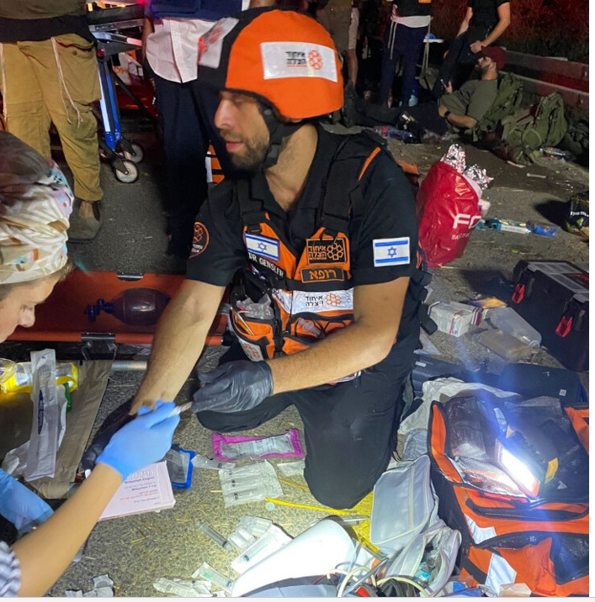

“You could see they suffered as they died,” he recounted. “We saw the inhumanity of individuals. Helping the injured was surreal and it took time to set in. We had the opportunity to treat hundreds of people, whether with pain control, bandaging or life-saving measures.”

Gensler and his fellow doctors and medics worked until 6 am.

He reflects on meeting a grandmother who told him that her grandkids were trapped in the *mamad* (safe room) of one of the homes in Kfar Aza. She knew exactly where they were and wanted to get them out. Dr. Gensler notified the army who then went in and retrieved the kids.

“They told us they saw their parents executed in front of them. Then they told me they were hungry and had not eaten in the last 12 hours,” Dr. Gensler said. “I walked away to cry.”

Dr. Gensler took a moment by himself. He spoke of witnessing their pain, suffering and finally their human need to have food. These new orphans were between eight and ten years old.

Moments later, he returned to his work

**A Time for Action**

“I’ve been able to reflect on that and talk it over and process it. That moment wasn't the time to do that. It was a time of action.”

Gensler saw terrorists captured by Israel. He noted Israeli officers did not beat up Hamas terrorists. Instead, they handcuffed them and allowed them to sit quietly.

“It was something not afforded to the other side,” he said. “The contrast was quite apparent. “

The doctor also spoke of a 90-year-old woman who survived a bullet through her chest because it did not strike any of her organs. The brutality caught all walks of life.

"There was a big dichotomy between the barbarity of these individuals and what they perpetrated to the kindness and charitableness [of Israelis] and people willing to risk their lives for Israel," Dr. Gensler said.

**Unable to Remember all the People He Treated that Day**

When asked about the volume of patients he treated that day, Dr. Gensler says he treated so many people that he cannot even remember each patient.

“There was a lot of stuff I did really fast without much time to waste. I’ve been treating soldiers after the attack and have become close to them.”

Dr. Gensler was able to arrange a hospital exit for a sergeant who wanted to attend the funerals of two of his friends/comrades who were killed on that heinous day. “I discussed it with a colleague and said he was stable enough. We quickly arranged an ambulance. It was very therapeutic for him. He was able to feel he had enough control to go to his best friends’ funerals. They were fighting together valiantly.”

Because the soldier needed a doctor to supervise him at the funeral, Dr. Gensler accompanied him. “I got to be with him at the funeral of his two closest friends,” he said.

“People are there for each other in a strong way,” Dr. Gensler said. “You see the amount of giving and caring even in a nation that is suffering.”

The 38-year-old grew up between the U.S. and Canada, went to medical school alongside his wife at the Technion medical school (whom he believes is a better, smarter doctor) and decided to stay in Jerusalem and raise a family.

Dr. Gensler reflects on being called into action that fateful day.

“I have a skill set that enables me to be there at a time of need. It's a humbling feeling. I feel honestly privileged to be able to help people and I hope I can do what's right,” he said. “I definitely feel that the cascading of events was something I was able to put years and years of training into moments of real need.”

Reprinted from the November 7, 2023 website of aish.com

**Last Thought on the Parsha**

Although Isaac had carried on his conversation with Esau in a whisper, Rivka had heard it as loudly as if he were speaking in a normal tone. She thus interpreted it as a sign from Above to intervene. (The Rebbe of Dinov)

*Reprinted from the Parshat Toldot 5761/2000 edition of L’Chaim.*

**A Message from Rabbi Moshe Bryski**

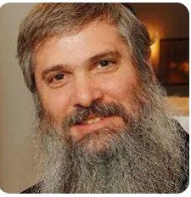`

We are witnessing a movement. An awakening.

In Israel and abroad, Jews who have not felt strongly connected to Israel or the Jewish people are suddenly feeling pulled to do more (and more) mitzvot.

People who have not stepped foot in a synagogue in decades are now showing up for services. Thousands of pairs of tefillin have been donated. Tens of thousands of women worldwide are lighting Shabbat candles, many for the first time. People who just a few weeks ago couldn’t see eye-to-eye religiously or politically are now hugging each other on the streets.

As I witness this outpouring, I honestly wonder, why? Why has atrocity caused this spiritual awakening? Why does suffering create such an expression of unity?

What we are witnessing right now is the Jewish soul screaming, G‑d, I want to connect with you.

The trivial things that were taking up so much of our energy have been crushed. The curtain has been pulled back, and the façade of our reality has crumbled, leaving our essence exposed.

So, I do an extra mitzvah, because G‑d, You are the only eternal truth. I connect with my fellow Jew, because no matter how much we quibble or disagree, we are one. I know this not because I have read or studied it, not because I can even express it in words, but because my soul intuitively understands.

Because right now, deep down, we feel—no, we know!—with certainty, that we are the People whom G‑d promised will succeed in transforming the evil and depravity of this world to usher in the greatest light, morality, and peace for all humanity.

With heartfelt prayers for the safety of the Jewish People and the immediate return of all the hostages.

*Rabbi Bryski is the rabbi of Chabad of the Canejo in California. Reprinted the shul’s Parshat Chaya Sarah 5784 weekly email.*